Cell Transport
- What is a solute? ______________________________________________________________________
- What is a solvent? _____________________________________________________________________
- What is a solution? ____________________________________________________________________
- What is concentration? How is it measured? _______________________________________________ _____________________________________________________________________________________
- Why is the cell membrane referred to as the selectively permeable membrane? __________________ _____________________________________________________________________________________
- What is Passive Transport? ______________________________________________________________
  - What are 3 types of passive transport – describe each
    - ________________________________________________________________________________________________________________________________________________
    - ________________________________________________________________________________________________________________________________________________
    - ________________________________________________________________________________________________________________________________________________
- What is Active Transport? ______________________________________________________________
  - What are 3 types of active transport – describe each
    - ________________________________________________________________________________________________________________________________________________
    - ________________________________________________________________________________________________________________________________________________
    - ________________________________________________________________________________________________________________________________________________
- What is tonicity? ______________________________________________________________________
- Tonic Solutions – Fill in the following table:
 | Hypertonic | Hypotonic | Isotonic
Definition:
What happens to the cell?
Draw 2 pictures, a before and after, of a cell in each solution?
Food Chain/Trophic Levels/Energy Pyramid
- What are the trophic levels in order starting with the sun? Define each.
  - ______________________________________________________________________________
  - ______________________________________________________________________________
  - ______________________________________________________________________________
  - ______________________________________________________________________________
- Label the energy pyramid and write the amount of energy available to the subsequent trophic levels if the sun started off with 5,000,000 J of energy.
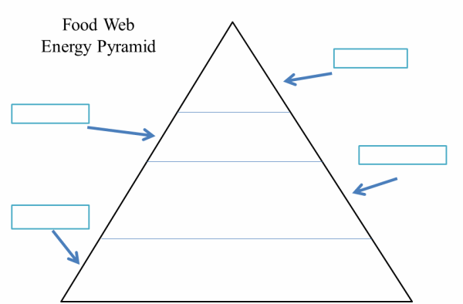

- Define heterotroph: ____________________________________________________________________
- Define autotroph: _____________________________________________________________________
Photosynthesis
- What is goal of photosynthesis? __________________________________________________________
- Where does photosynthesis occur? ____________________
- What is the stroma? ____________________________________________________________________
- What is a thylakoid? ____________________________________________________________________
- What are grana? _______________________________________________________________________
- What is chlorophyll and where is it found? __________________________________________________ _____________________________________________________________________________________
- What wavelengths of light does chlorophyll absorb? ___________________
- What wavelengths of light does chlorophyll reflect? ____________________
- What are the light dependent reactions? ___________________________________________________ _____________________________________________________________________________________
- What is the Calvin cycle? ________________________________________________________________ _____________________________________________________________________________________
- What does the Calvin cycle produce using CO₂ molecules? ____________
- Write the chemical equation for photosynthesis: _____________________________________________________________________________________

- Where do the reactants for photosynthesis come from? _______________________________________ _____________________________________________________________________________________
- What happens to the products of photosynthesis? ____________________________________________ _____________________________________________________________________________________
- What are the stomata? __________________________________________________________________
- Label the stroma, thylakoids, and grana of the following chloroplast:
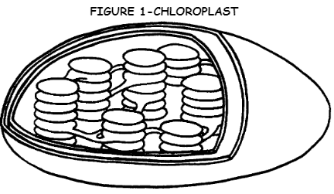

Cellular Respiration
- Where does cellular respiration take place? _____________________
- Where does glycolysis take place? ______________________
- What is glycolysis? _____________________________________________________________________
- What is released when a chemical bond is broken? __________
- What process occurs in an aerobic environment? ________________________
- What process occurs in an anaerobic environment? ________________________
- What is the Kreb’s cycle? ________________________________________________________________ _____________________________________________________________________________________
- What is the Electron Transport Chain? _____________________________________________________ _____________________________________________________________________________________
- How many ATP are produced for every molecule of glucose? _______
- What are the waste products of cellular respiration? _____________________________
- Write the cellular respiration equation:
_____________________________________________________________________________________
- What are important relationships between the photosynthesis reaction and the cellular respiration reaction? _____________________________________________________________________________ __________________________________________________________________________________________________________________________________________________________________________

- Label the outer membrane, inner membrane space, and the matrix of the following mitochondria:
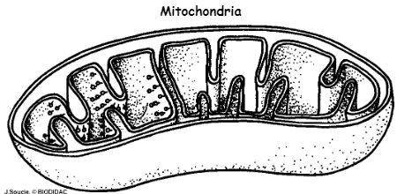

Fermentation
- When does fermentation occur? _________________________________________________________
- Where in a cell does fermentation occur? ______________________
- What does fermentation produce? ________________________________________________________
- What are the 2 types of fermentation? In addition to ATP, what important product does each reaction produce? What are some examples of food products that are made via fermentation? Indicate which reaction occurs in muscle tissues, and the painful side effect that it causes.
  - ______________________________________________________________________________ ______________________________________________________________________________ ______________________________________________________________________________
  - ______________________________________________________________________________
______________________________________________________________________________ ______________________________________________________________________________

